**Prelab-Week-2**

**Prelab Questions:**

1. List the asymptotic notations used to represent time complexity of an algorithm

2. List different methods to represent a graph. Represent the graph given below

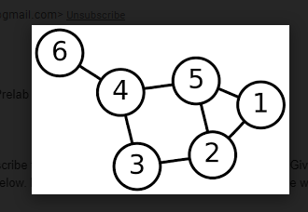

3. Which graph traversal can be used to determine the connected components in a graph?

4. Write the algorithm to detect a cycle in a graph using BFS.

Compute the time complexity of the designed algorithm.

5. Write the algorithm to determine the degree of a graph. Compute the time complexity of the designed algorithm.

**Prelab Programs:**

1. Implement Depth First Search (DFS) tree traversal by representing graph in Adjacency matrix and by Adjacency list.

2. Implement Breadth first search (BFS) tree traversal by representing graph in Adjacency matrix and also by Adjacency list.

3. Implement connected components with appropriate graph traversal.

4. Implement topological sort using appropriate graph traversal.